CROSS JOIN

EQUI JOIN / INNER JOIN

DIFF BETWEEN CROSS JOIN AND EQUI JOIN IS WHERE CONDITION ONLY.

JOINS ARE USED TO DISPLAY DATA FROM MULTIPLE TABLES.

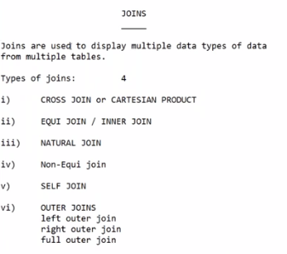

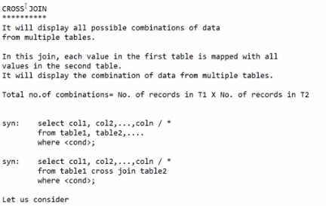

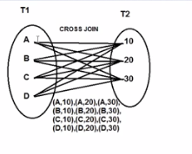

HERE WE HAVE SOME VALID COMBINATIONS AND INVALID COMBINATIONS ALSO.

BUT WE CAN GET VALID COMBINATIONS ONLY BY USING EQUI JOIN.

WITHOUT CROSS JOIN KEYWORD ALSO WE CAN PERFORM CROSS JOIN.

SQL> SELECT \* FROM EMP;

EMPNO ENAME JOB MGR HIREDATE SAL COMM

---------- ---------- --------- ---------- --------- ---------- ----------

DEPTNO

----------

7839 KING PRESIDENT 17-NOV-81 5000

10

7698 BLAKE MANAGER 7839 01-MAY-81 2850

30

7782 CLARK MANAGER 7839 09-JUN-81 2450

10

EMPNO ENAME JOB MGR HIREDATE SAL COMM

---------- ---------- --------- ---------- --------- ---------- ----------

DEPTNO

----------

7566 JONES MANAGER 7839 02-APR-81 2975

20

7788 SCOTT ANALYST 7566 19-APR-87 3000

20

7902 FORD ANALYST 7566 03-DEC-81 3000

20

EMPNO ENAME JOB MGR HIREDATE SAL COMM

---------- ---------- --------- ---------- --------- ---------- ----------

DEPTNO

----------

7369 SMITH CLERK 7902 17-DEC-80 800

20

7499 ALLEN SALESMAN 7698 20-FEB-81 1600 300

30

7521 WARD SALESMAN 7698 22-FEB-81 1250 500

30

EMPNO ENAME JOB MGR HIREDATE SAL COMM

---------- ---------- --------- ---------- --------- ---------- ----------

DEPTNO

----------

7654 MARTIN SALESMAN 7698 28-SEP-81 1250 1400

30

7844 TURNER SALESMAN 7698 08-SEP-81 1500 0

30

7876 ADAMS CLERK 7788 23-MAY-87 1100

20

EMPNO ENAME JOB MGR HIREDATE SAL COMM

---------- ---------- --------- ---------- --------- ---------- ----------

DEPTNO

----------

7900 JAMES CLERK 7698 03-DEC-81 950

30

7934 MILLER CLERK 7782 23-JAN-82 1300

10

14 rows selected.

SQL> SELECT \* FROM DEPT;

DEPTNO DNAME LOC MANAGER

---------- -------------- ------------- ----------

10 ACCOUNTING NEW YORK

20 RESEARCH DALLAS

30 SALES CHICAGO

40 OPERATIONS BOSTON

SQL> SELECT E.\*, D.\* FROM EMP E, DEPT D

2 ;

EMPNO ENAME JOB MGR HIREDATE SAL COMM

---------- ---------- --------- ---------- --------- ---------- ----------

DEPTNO DEPTNO DNAME LOC MANAGER

---------- ---------- -------------- ------------- ----------

7839 KING PRESIDENT 17-NOV-81 5000

10 10 ACCOUNTING NEW YORK

7698 BLAKE MANAGER 7839 01-MAY-81 2850

30 10 ACCOUNTING NEW YORK

7782 CLARK MANAGER 7839 09-JUN-81 2450

10 10 ACCOUNTING NEW YORK

EMPNO ENAME JOB MGR HIREDATE SAL COMM

---------- ---------- --------- ---------- --------- ---------- ----------

DEPTNO DEPTNO DNAME LOC MANAGER

---------- ---------- -------------- ------------- ----------

7566 JONES MANAGER 7839 02-APR-81 2975

20 10 ACCOUNTING NEW YORK

7788 SCOTT ANALYST 7566 19-APR-87 3000

20 10 ACCOUNTING NEW YORK

7902 FORD ANALYST 7566 03-DEC-81 3000

20 10 ACCOUNTING NEW YORK

EMPNO ENAME JOB MGR HIREDATE SAL COMM

---------- ---------- --------- ---------- --------- ---------- ----------

DEPTNO DEPTNO DNAME LOC MANAGER

---------- ---------- -------------- ------------- ----------

7369 SMITH CLERK 7902 17-DEC-80 800

20 10 ACCOUNTING NEW YORK

7499 ALLEN SALESMAN 7698 20-FEB-81 1600 300

30 10 ACCOUNTING NEW YORK

7521 WARD SALESMAN 7698 22-FEB-81 1250 500

30 10 ACCOUNTING NEW YORK

EMPNO ENAME JOB MGR HIREDATE SAL COMM

---------- ---------- --------- ---------- --------- ---------- ----------

DEPTNO DEPTNO DNAME LOC MANAGER

---------- ---------- -------------- ------------- ----------

7654 MARTIN SALESMAN 7698 28-SEP-81 1250 1400

30 10 ACCOUNTING NEW YORK

7844 TURNER SALESMAN 7698 08-SEP-81 1500 0

30 10 ACCOUNTING NEW YORK

7876 ADAMS CLERK 7788 23-MAY-87 1100

20 10 ACCOUNTING NEW YORK

EMPNO ENAME JOB MGR HIREDATE SAL COMM

---------- ---------- --------- ---------- --------- ---------- ----------

DEPTNO DEPTNO DNAME LOC MANAGER

---------- ---------- -------------- ------------- ----------

7900 JAMES CLERK 7698 03-DEC-81 950

30 10 ACCOUNTING NEW YORK

7934 MILLER CLERK 7782 23-JAN-82 1300

10 10 ACCOUNTING NEW YORK

7839 KING PRESIDENT 17-NOV-81 5000

10 20 RESEARCH DALLAS

EMPNO ENAME JOB MGR HIREDATE SAL COMM

---------- ---------- --------- ---------- --------- ---------- ----------

DEPTNO DEPTNO DNAME LOC MANAGER

---------- ---------- -------------- ------------- ----------

7698 BLAKE MANAGER 7839 01-MAY-81 2850

30 20 RESEARCH DALLAS

7782 CLARK MANAGER 7839 09-JUN-81 2450

10 20 RESEARCH DALLAS

7566 JONES MANAGER 7839 02-APR-81 2975

20 20 RESEARCH DALLAS

EMPNO ENAME JOB MGR HIREDATE SAL COMM

---------- ---------- --------- ---------- --------- ---------- ----------

DEPTNO DEPTNO DNAME LOC MANAGER

---------- ---------- -------------- ------------- ----------

7788 SCOTT ANALYST 7566 19-APR-87 3000

20 20 RESEARCH DALLAS

7902 FORD ANALYST 7566 03-DEC-81 3000

20 20 RESEARCH DALLAS

7369 SMITH CLERK 7902 17-DEC-80 800

20 20 RESEARCH DALLAS

EMPNO ENAME JOB MGR HIREDATE SAL COMM

---------- ---------- --------- ---------- --------- ---------- ----------

DEPTNO DEPTNO DNAME LOC MANAGER

---------- ---------- -------------- ------------- ----------

7499 ALLEN SALESMAN 7698 20-FEB-81 1600 300

30 20 RESEARCH DALLAS

7521 WARD SALESMAN 7698 22-FEB-81 1250 500

30 20 RESEARCH DALLAS

7654 MARTIN SALESMAN 7698 28-SEP-81 1250 1400

30 20 RESEARCH DALLAS

EMPNO ENAME JOB MGR HIREDATE SAL COMM

---------- ---------- --------- ---------- --------- ---------- ----------

DEPTNO DEPTNO DNAME LOC MANAGER

---------- ---------- -------------- ------------- ----------

7844 TURNER SALESMAN 7698 08-SEP-81 1500 0

30 20 RESEARCH DALLAS

7876 ADAMS CLERK 7788 23-MAY-87 1100

20 20 RESEARCH DALLAS

7900 JAMES CLERK 7698 03-DEC-81 950

30 20 RESEARCH DALLAS

EMPNO ENAME JOB MGR HIREDATE SAL COMM

---------- ---------- --------- ---------- --------- ---------- ----------

DEPTNO DEPTNO DNAME LOC MANAGER

---------- ---------- -------------- ------------- ----------

7934 MILLER CLERK 7782 23-JAN-82 1300

10 20 RESEARCH DALLAS

7839 KING PRESIDENT 17-NOV-81 5000

10 30 SALES CHICAGO

7698 BLAKE MANAGER 7839 01-MAY-81 2850

30 30 SALES CHICAGO

EMPNO ENAME JOB MGR HIREDATE SAL COMM

---------- ---------- --------- ---------- --------- ---------- ----------

DEPTNO DEPTNO DNAME LOC MANAGER

---------- ---------- -------------- ------------- ----------

7782 CLARK MANAGER 7839 09-JUN-81 2450

10 30 SALES CHICAGO

7566 JONES MANAGER 7839 02-APR-81 2975

20 30 SALES CHICAGO

7788 SCOTT ANALYST 7566 19-APR-87 3000

20 30 SALES CHICAGO

EMPNO ENAME JOB MGR HIREDATE SAL COMM

---------- ---------- --------- ---------- --------- ---------- ----------

DEPTNO DEPTNO DNAME LOC MANAGER

---------- ---------- -------------- ------------- ----------

7902 FORD ANALYST 7566 03-DEC-81 3000

20 30 SALES CHICAGO

7369 SMITH CLERK 7902 17-DEC-80 800

20 30 SALES CHICAGO

7499 ALLEN SALESMAN 7698 20-FEB-81 1600 300

30 30 SALES CHICAGO

EMPNO ENAME JOB MGR HIREDATE SAL COMM

---------- ---------- --------- ---------- --------- ---------- ----------

DEPTNO DEPTNO DNAME LOC MANAGER

---------- ---------- -------------- ------------- ----------

7521 WARD SALESMAN 7698 22-FEB-81 1250 500

30 30 SALES CHICAGO

7654 MARTIN SALESMAN 7698 28-SEP-81 1250 1400

30 30 SALES CHICAGO

7844 TURNER SALESMAN 7698 08-SEP-81 1500 0

30 30 SALES CHICAGO

EMPNO ENAME JOB MGR HIREDATE SAL COMM

---------- ---------- --------- ---------- --------- ---------- ----------

DEPTNO DEPTNO DNAME LOC MANAGER

---------- ---------- -------------- ------------- ----------

7876 ADAMS CLERK 7788 23-MAY-87 1100

20 30 SALES CHICAGO

7900 JAMES CLERK 7698 03-DEC-81 950

30 30 SALES CHICAGO

7934 MILLER CLERK 7782 23-JAN-82 1300

10 30 SALES CHICAGO

EMPNO ENAME JOB MGR HIREDATE SAL COMM

---------- ---------- --------- ---------- --------- ---------- ----------

DEPTNO DEPTNO DNAME LOC MANAGER

---------- ---------- -------------- ------------- ----------

7839 KING PRESIDENT 17-NOV-81 5000

10 40 OPERATIONS BOSTON

7698 BLAKE MANAGER 7839 01-MAY-81 2850

30 40 OPERATIONS BOSTON

7782 CLARK MANAGER 7839 09-JUN-81 2450

10 40 OPERATIONS BOSTON

EMPNO ENAME JOB MGR HIREDATE SAL COMM

---------- ---------- --------- ---------- --------- ---------- ----------

DEPTNO DEPTNO DNAME LOC MANAGER

---------- ---------- -------------- ------------- ----------

7566 JONES MANAGER 7839 02-APR-81 2975

20 40 OPERATIONS BOSTON

7788 SCOTT ANALYST 7566 19-APR-87 3000

20 40 OPERATIONS BOSTON

7902 FORD ANALYST 7566 03-DEC-81 3000

20 40 OPERATIONS BOSTON

EMPNO ENAME JOB MGR HIREDATE SAL COMM

---------- ---------- --------- ---------- --------- ---------- ----------

DEPTNO DEPTNO DNAME LOC MANAGER

---------- ---------- -------------- ------------- ----------

7369 SMITH CLERK 7902 17-DEC-80 800

20 40 OPERATIONS BOSTON

7499 ALLEN SALESMAN 7698 20-FEB-81 1600 300

30 40 OPERATIONS BOSTON

7521 WARD SALESMAN 7698 22-FEB-81 1250 500

30 40 OPERATIONS BOSTON

EMPNO ENAME JOB MGR HIREDATE SAL COMM

---------- ---------- --------- ---------- --------- ---------- ----------

DEPTNO DEPTNO DNAME LOC MANAGER

---------- ---------- -------------- ------------- ----------

7654 MARTIN SALESMAN 7698 28-SEP-81 1250 1400

30 40 OPERATIONS BOSTON

7844 TURNER SALESMAN 7698 08-SEP-81 1500 0

30 40 OPERATIONS BOSTON

7876 ADAMS CLERK 7788 23-MAY-87 1100

20 40 OPERATIONS BOSTON

EMPNO ENAME JOB MGR HIREDATE SAL COMM

---------- ---------- --------- ---------- --------- ---------- ----------

DEPTNO DEPTNO DNAME LOC MANAGER

---------- ---------- -------------- ------------- ----------

7900 JAMES CLERK 7698 03-DEC-81 950

30 40 OPERATIONS BOSTON

7934 MILLER CLERK 7782 23-JAN-82 1300

10 40 OPERATIONS BOSTON

56 rows selected.

SQL> SELECT ENAME, DNAME FROM EMP , DEPT;

ENAME DNAME

---------- --------------

KING ACCOUNTING

BLAKE ACCOUNTING

CLARK ACCOUNTING

JONES ACCOUNTING

SCOTT ACCOUNTING

FORD ACCOUNTING

SMITH ACCOUNTING

ALLEN ACCOUNTING

WARD ACCOUNTING

MARTIN ACCOUNTING

TURNER ACCOUNTING

ENAME DNAME

---------- --------------

ADAMS ACCOUNTING

JAMES ACCOUNTING

MILLER ACCOUNTING

KING RESEARCH

BLAKE RESEARCH

CLARK RESEARCH

JONES RESEARCH

SCOTT RESEARCH

FORD RESEARCH

SMITH RESEARCH

ALLEN RESEARCH

ENAME DNAME

---------- --------------

WARD RESEARCH

MARTIN RESEARCH

TURNER RESEARCH

ADAMS RESEARCH

JAMES RESEARCH

MILLER RESEARCH

KING SALES

BLAKE SALES

CLARK SALES

JONES SALES

SCOTT SALES

ENAME DNAME

---------- --------------

FORD SALES

SMITH SALES

ALLEN SALES

WARD SALES

MARTIN SALES

TURNER SALES

ADAMS SALES

JAMES SALES

MILLER SALES

KING OPERATIONS

BLAKE OPERATIONS

ENAME DNAME

---------- --------------

CLARK OPERATIONS

JONES OPERATIONS

SCOTT OPERATIONS

FORD OPERATIONS

SMITH OPERATIONS

ALLEN OPERATIONS

WARD OPERATIONS

MARTIN OPERATIONS

TURNER OPERATIONS

ADAMS OPERATIONS

JAMES OPERATIONS

ENAME DNAME

---------- --------------

MILLER OPERATIONS

56 rows selected.

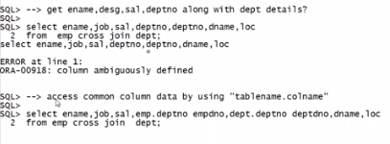

SQL> SELECT E.\*, D.\* FROM EMP E, DEPT D

2 WHERE E.DEPTNO=D.DEPTNO;

EMPNO ENAME JOB MGR HIREDATE SAL COMM

---------- ---------- --------- ---------- --------- ---------- ----------

DEPTNO DEPTNO DNAME LOC MANAGER

---------- ---------- -------------- ------------- ----------

7839 KING PRESIDENT 17-NOV-81 5000

10 10 ACCOUNTING NEW YORK

7698 BLAKE MANAGER 7839 01-MAY-81 2850

30 30 SALES CHICAGO

7782 CLARK MANAGER 7839 09-JUN-81 2450

10 10 ACCOUNTING NEW YORK

EMPNO ENAME JOB MGR HIREDATE SAL COMM

---------- ---------- --------- ---------- --------- ---------- ----------

DEPTNO DEPTNO DNAME LOC MANAGER

---------- ---------- -------------- ------------- ----------

7566 JONES MANAGER 7839 02-APR-81 2975

20 20 RESEARCH DALLAS

7788 SCOTT ANALYST 7566 19-APR-87 3000

20 20 RESEARCH DALLAS

7902 FORD ANALYST 7566 03-DEC-81 3000

20 20 RESEARCH DALLAS

EMPNO ENAME JOB MGR HIREDATE SAL COMM

---------- ---------- --------- ---------- --------- ---------- ----------

DEPTNO DEPTNO DNAME LOC MANAGER

---------- ---------- -------------- ------------- ----------

7369 SMITH CLERK 7902 17-DEC-80 800

20 20 RESEARCH DALLAS

7499 ALLEN SALESMAN 7698 20-FEB-81 1600 300

30 30 SALES CHICAGO

7521 WARD SALESMAN 7698 22-FEB-81 1250 500

30 30 SALES CHICAGO

EMPNO ENAME JOB MGR HIREDATE SAL COMM

---------- ---------- --------- ---------- --------- ---------- ----------

DEPTNO DEPTNO DNAME LOC MANAGER

---------- ---------- -------------- ------------- ----------

7654 MARTIN SALESMAN 7698 28-SEP-81 1250 1400

30 30 SALES CHICAGO

7844 TURNER SALESMAN 7698 08-SEP-81 1500 0

30 30 SALES CHICAGO

7876 ADAMS CLERK 7788 23-MAY-87 1100

20 20 RESEARCH DALLAS

EMPNO ENAME JOB MGR HIREDATE SAL COMM

---------- ---------- --------- ---------- --------- ---------- ----------

DEPTNO DEPTNO DNAME LOC MANAGER

---------- ---------- -------------- ------------- ----------

7900 JAMES CLERK 7698 03-DEC-81 950

30 30 SALES CHICAGO

7934 MILLER CLERK 7782 23-JAN-82 1300

10 10 ACCOUNTING NEW YORK

14 rows selected.

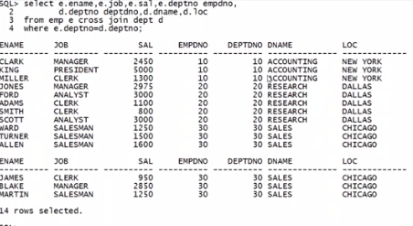

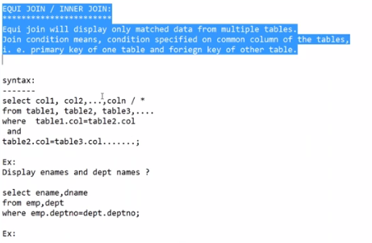

SQL> ED

Wrote file afiedt.buf

1 SELECT E.ENAME, D.\*

2 FROM EMP E CROSS JOIN DEPT D

3\* WHERE D.DEPTNO=E.DEPTNO

SQL> /

ENAME DEPTNO DNAME LOC MANAGER

---------- ---------- -------------- ------------- ----------

KING 10 ACCOUNTING NEW YORK

BLAKE 30 SALES CHICAGO

CLARK 10 ACCOUNTING NEW YORK

JONES 20 RESEARCH DALLAS

SCOTT 20 RESEARCH DALLAS

FORD 20 RESEARCH DALLAS

SMITH 20 RESEARCH DALLAS

ALLEN 30 SALES CHICAGO

WARD 30 SALES CHICAGO

MARTIN 30 SALES CHICAGO

TURNER 30 SALES CHICAGO

ENAME DEPTNO DNAME LOC MANAGER

---------- ---------- -------------- ------------- ----------

ADAMS 20 RESEARCH DALLAS

JAMES 30 SALES CHICAGO

MILLER 10 ACCOUNTING NEW YORK

14 rows selected.

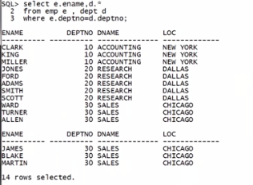

SQL> --GET MANAGER NAMES , SALARIES, JOBS, DEPTNO, AND CORRECPONDING DEPT DETAILS AND ORDER THE DATA BASED ON SALARIES.

SQL> ED

Wrote file afiedt.buf

1 SELECT E.ENAME, E.SAL, E.JOB, E.DEPTNO, D.\*

2 FROM EMP E, DEPT D

3 WHERE E.DEPTNO=D.DEPTNO AND JOB = 'MANAGER'

4\* ORDER BY E.SAL

SQL> /

ENAME SAL JOB DEPTNO DEPTNO DNAME

---------- ---------- --------- ---------- ---------- --------------

LOC MANAGER

------------- ----------

CLARK 2450 MANAGER 10 10 ACCOUNTING

NEW YORK

BLAKE 2850 MANAGER 30 30 SALES

CHICAGO

JONES 2975 MANAGER 20 20 RESEARCH

DALLAS

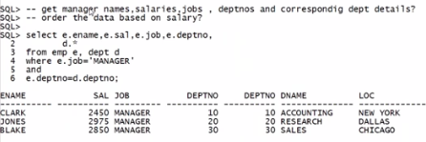

HERE CONDITION IN WHERE CLAUSE IS VERY VERY IMP., WE CAN NOT CHANGE THE ORDER THERE.